**CSE 100 Homework #4**

**Andrew Ng**

**Priscilla Law**

**Kyle Stephan**

**Exercise 1:**

**1)**

DFS(G)

**for** each vertex u ∈ G.V

u.color = WHITE

u.𝝅 = NIL

time = 0

**for** each vertex u ∈ G.V //modify this?

**if** u.color == WHITE

DFS-Visit(G, u)

DFS-Visit(G, u)

time = time+ 1  
 u.d = time

u.color = GRAY

**for** each v ∈ G.Adj[u]

**if** v.color == WHITE

v.𝝅 = u

DFS-Visit(G, v)

u.color = BLACK

time = time + 1

u.f = time

**2)**

BFS(G, s) // -> BFS-Connected-Components(G)

**for** each vertex u ∈ G.V - {s}

u.color = WHITE

u.d = ∞

u.𝝅 = NIL

s.color = GRAY

s.d = 0

s.𝝅 = NIL

Q = Ø

ENQUEUE(Q, s)

u = DEQUEUE(Q)

**for** each v.color == WHITE

v.color = GRAY

v.d = u.d + 1

v.𝝅 = u

ENQUEUE(Q, v)

u.color = BLACK

**3)** Runtime of BFS-Connected-Components is...

**Exercise 2:**

1. **Adjacency - List: G**

|  |  |  |  |  |  |  |  |  |  |
| --- | --- | --- | --- | --- | --- | --- | --- | --- | --- |
| **A** | **→** | **C** | **→** | **E** | **→** | **F** | **→** | **H** | **X** |
| **B** | **→** | **C** | **→** | **F** | **X** |  |  |  |  |
| **C** | **X** |  |  |  |  |  |  |  |  |
| **D** | **→** | **E** | **→** | **I** | **X** |  |  |  |  |
| **E** | **→** | **B** | **→** | **F** | **X** |  |  |  |  |
| **F** | **→** | **C** | **→** | **E** | **X** |  |  |  |  |
| **G** | **→** | **D** | **→** | **J** | **X** |  |  |  |  |
| **H** | **→** | **A** | **→** | **D** | **→** | **G** | **X** |  |  |
| **I** | **→** | **B** | **→** | **D** | **→** | **J** | **X** |  |  |
| **J** | **→** | **G** | **X** |  |  |  |  |  |  |

**2) Adjacency Matrix: G**

|  |  |  |  |  |  |  |  |  |  |  |
| --- | --- | --- | --- | --- | --- | --- | --- | --- | --- | --- |
|  | **A** | **B** | **C** | **D** | **E** | **F** | **G** | **H** | **I** | **J** |
| **A** | **0** | **0** | **1** | **0** | **1** | **1** | **0** | **1** | **0** | **0** |
| **B** | **0** | **0** | **1** | **0** | **0** | **1** | **0** | **0** | **0** | **0** |
| **C** | **0** | **0** | **0** | **0** | **0** | **0** | **0** | **0** | **0** | **0** |
| **D** | **0** | **0** | **0** | **0** | **1** | **0** | **0** | **0** | **1** | **0** |
| **E** | **0** | **1** | **0** | **0** | **0** | **1** | **0** | **0** | **0** | **0** |
| **F** | **0** | **0** | **1** | **0** | **1** | **0** | **0** | **0** | **0** | **0** |
| **G** | **0** | **0** | **0** | **1** | **0** | **0** | **0** | **0** | **0** | **1** |
| **H** | **1** | **0** | **0** | **1** | **0** | **0** | **1** | **0** | **0** | **0** |
| **I** | **0** | **1** | **0** | **1** | **0** | **0** | **0** | **0** | **0** | **1** |
| **J** | **0** | **0** | **0** | **0** | **0** | **0** | **1** | **0** | **0** | **0** |

**3) GT Graph:**

**GT Adjacency - List:**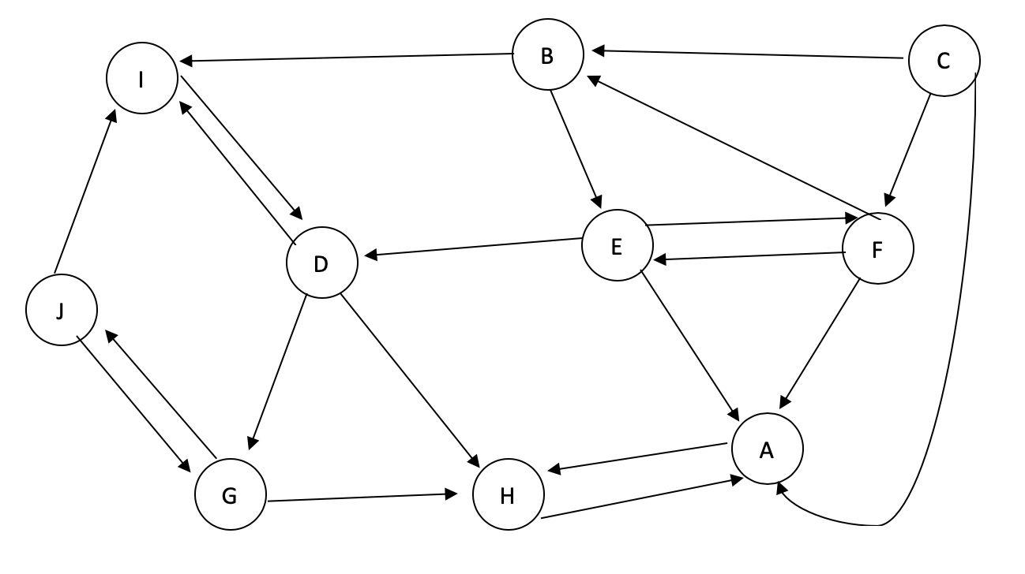

|  |  |  |  |  |  |  |  |  |  |
| --- | --- | --- | --- | --- | --- | --- | --- | --- | --- |
| **A** | **→** | **H** | **X** |  |  |  |  |  |  |
| **B** | **→** | **E** | **→** | **I** | **X** |  |  |  |  |
| **C** | **→** | **A** | **→** | **B** | **→** | **F** | **X** |  |  |
| **D** | **→** | **G** | **→** | **H** | **→** | **I** | **X** |  |  |
| **E** | **→** | **A** | **→** | **D** | **→** | **F** | **X** |  |  |
| **F** | **→** | **A** | **→** | **B** | **→** | **E** | **X** |  |  |
| **G** | **→** | **H** | **→** | **J** | **X** |  |  |  |  |
| **H** | **→** | **A** | **X** |  |  |  |  |  |  |
| **I** | **→** | **D** | **X** |  |  |  |  |  |  |
| **J** | **→** | **G** | **→** | **I** | **X** |  |  |  |  |

**GT Adjacency Matrix:**

|  |  |  |  |  |  |  |  |  |  |  |
| --- | --- | --- | --- | --- | --- | --- | --- | --- | --- | --- |
|  | **A** | **B** | **C** | **D** | **E** | **F** | **G** | **H** | **I** | **J** |
| **A** | **0** | **0** | **0** | **0** | **0** | **0** | **0** | **1** | **0** | **0** |
| **B** | **0** | **0** | **0** | **0** | **1** | **0** | **0** | **0** | **1** | **0** |
| **C** | **1** | **1** | **0** | **0** | **0** | **1** | **0** | **0** | **0** | **0** |
| **D** | **0** | **0** | **0** | **0** | **0** | **0** | **1** | **1** | **1** | **0** |
| **E** | **1** | **0** | **0** | **1** | **0** | **1** | **0** | **0** | **0** | **0** |
| **F** | **1** | **1** | **0** | **0** | **1** | **0** | **0** | **0** | **0** | **0** |
| **G** | **0** | **0** | **0** | **0** | **0** | **0** | **0** | **1** | **0** | **1** |
| **H** | **1** | **0** | **0** | **0** | **0** | **0** | **0** | **0** | **0** | **0** |
| **I** | **0** | **0** | **0** | **1** | **0** | **0** | **0** | **0** | **0** | **0** |
| **J** | **0** | **0** | **0** | **0** | **0** | **0** | **1** | **0** | **1** | **0** |

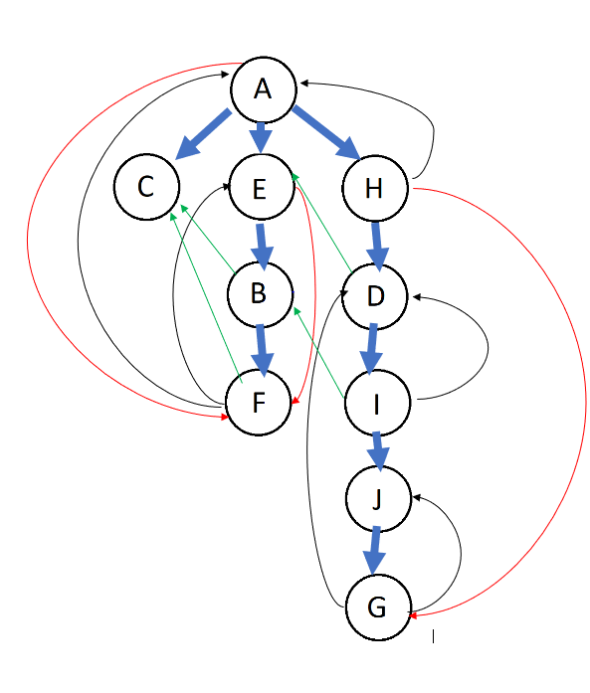

**4) Depth First Search of G:**

**Blue: Tree Edge**

**Black: Backwards Edge**

**Red: Forwards Edge**

**Green: Cross**

**Starting and finishing times:**

**A: (1/20)**

**B: (5/8)**

**C: (2/3)**

**D: (11/18)**

**E: (4/9)**

**F: (6/7)**

**G: (14/15)**

**H: (10/19)**

**I: (12/17)**

**J: (13/16)**

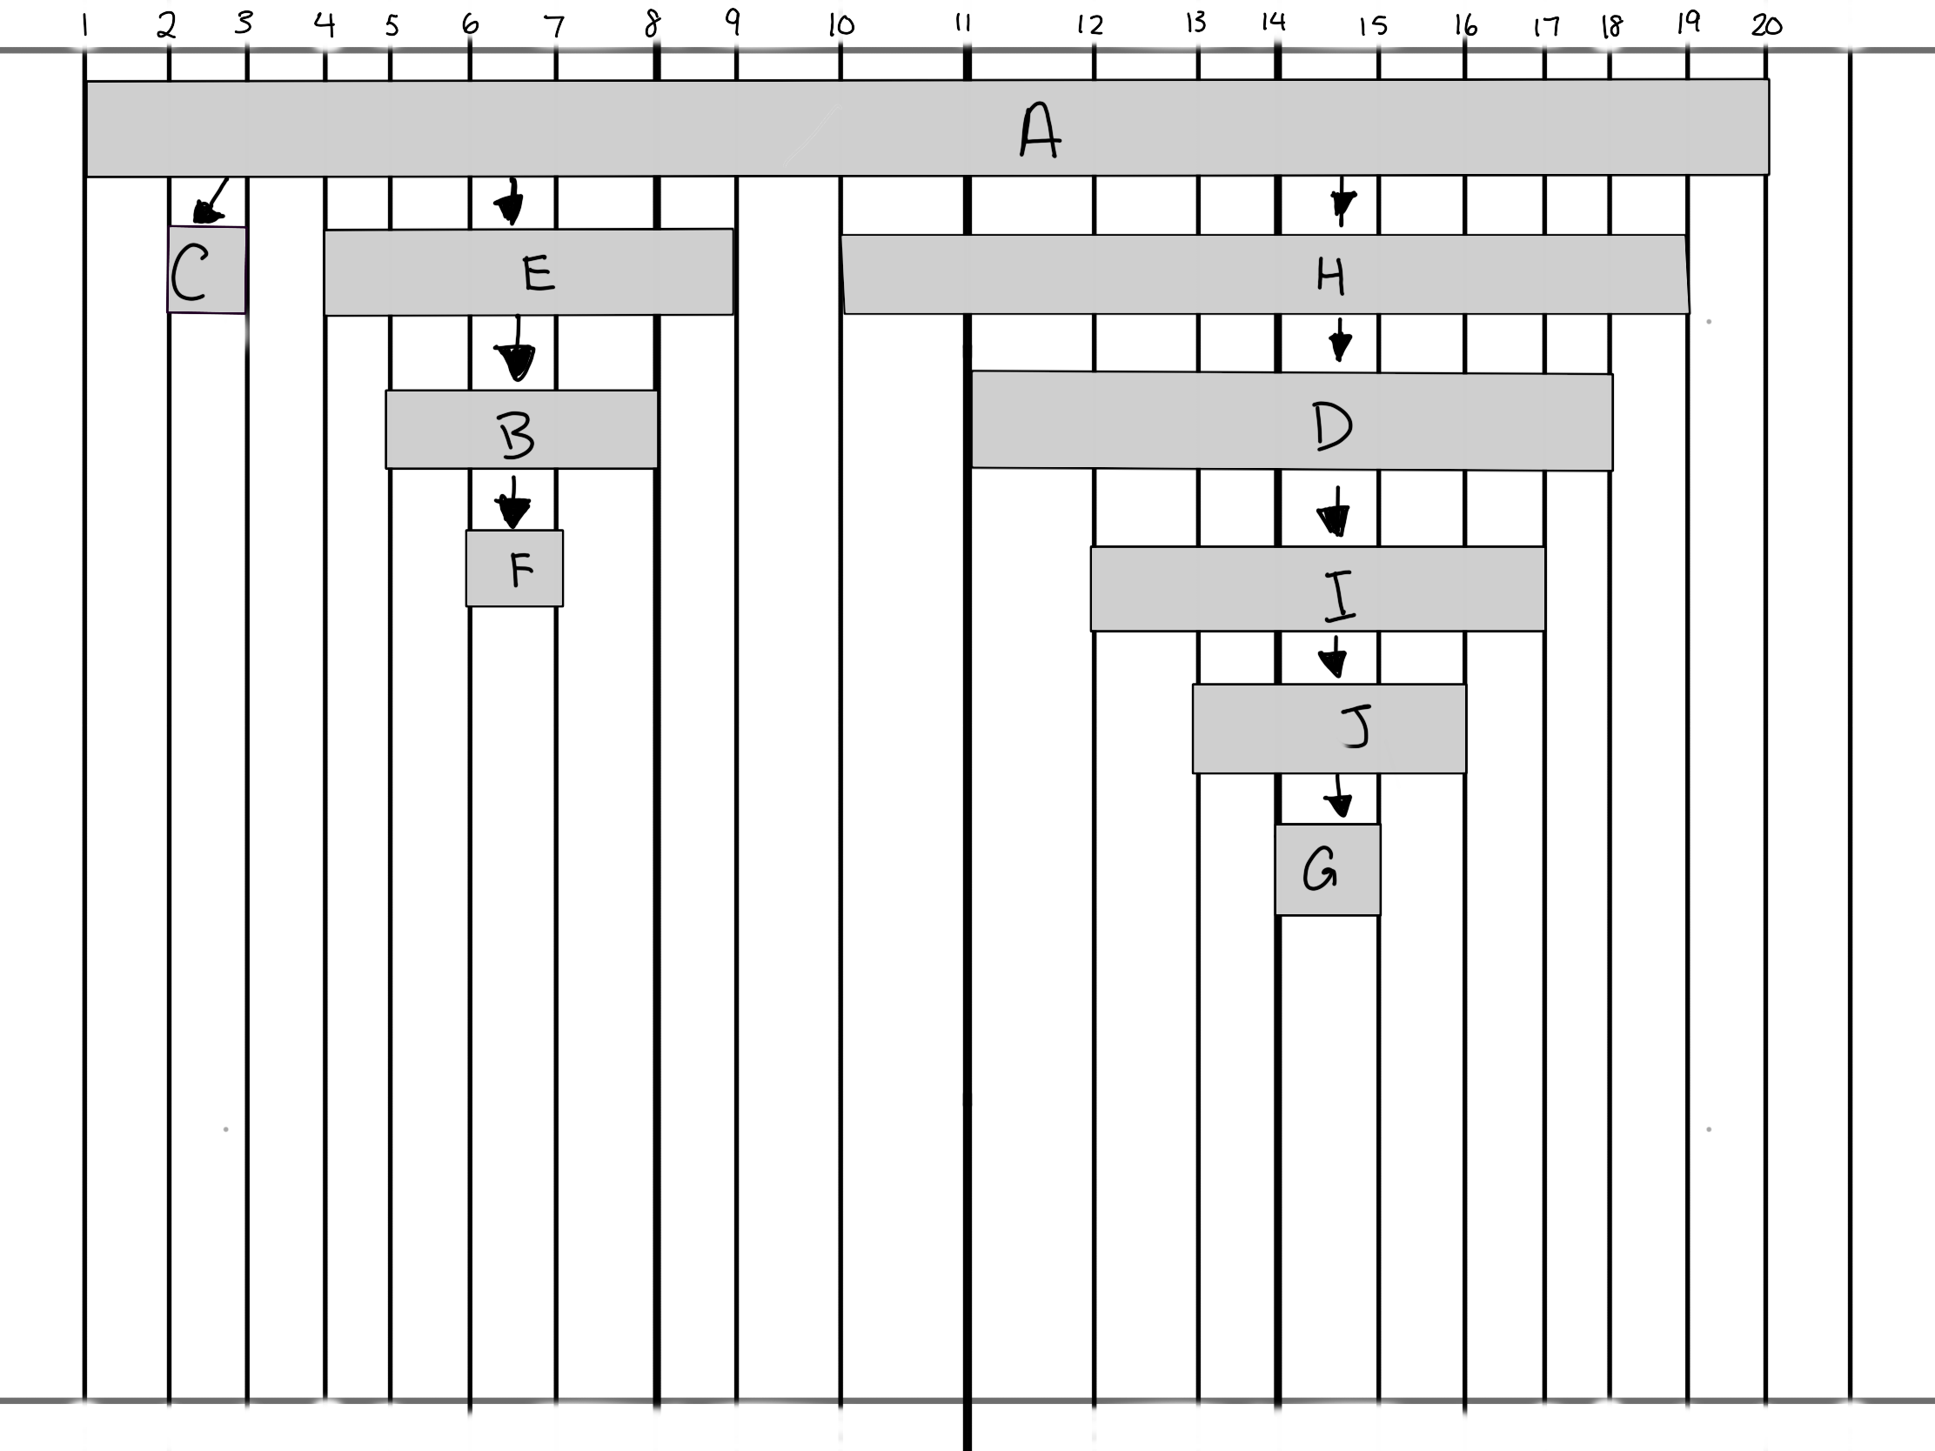

**5)**

The strongly connected components of G would be:  
1. A-H

2.E-F-B

3. D-G-I-J

4. C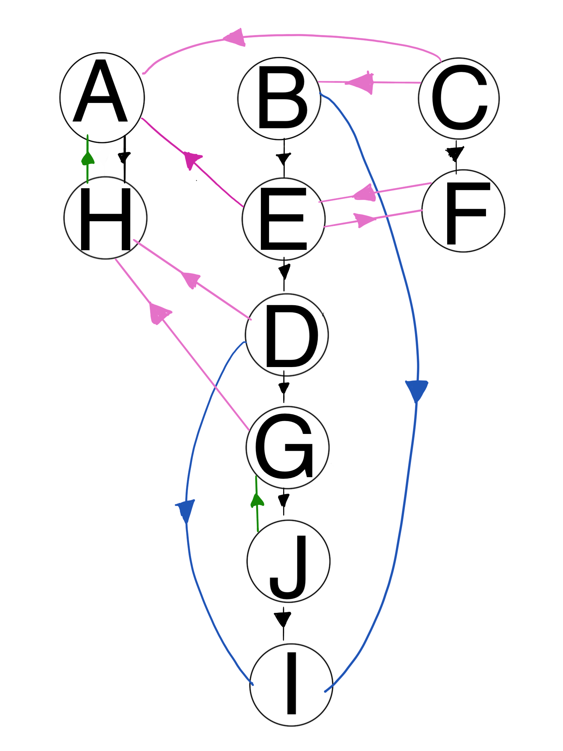

**Depth First Search GT:**

**Black: Tree Edge**

**Blue: Forward Edge**

**Green: Backward Edge**

**Pink: Cross**

**Starting and finishing times:**

**A: (1/4)**

**B: (5/16)**

**C: (17/20)**

**D: (7/13)**

**E: (6/15)**

**F: (18/19)**

**G: (8/13)**

**H: (2/3)**

**I: (10/11)**

**J: (9/12)**

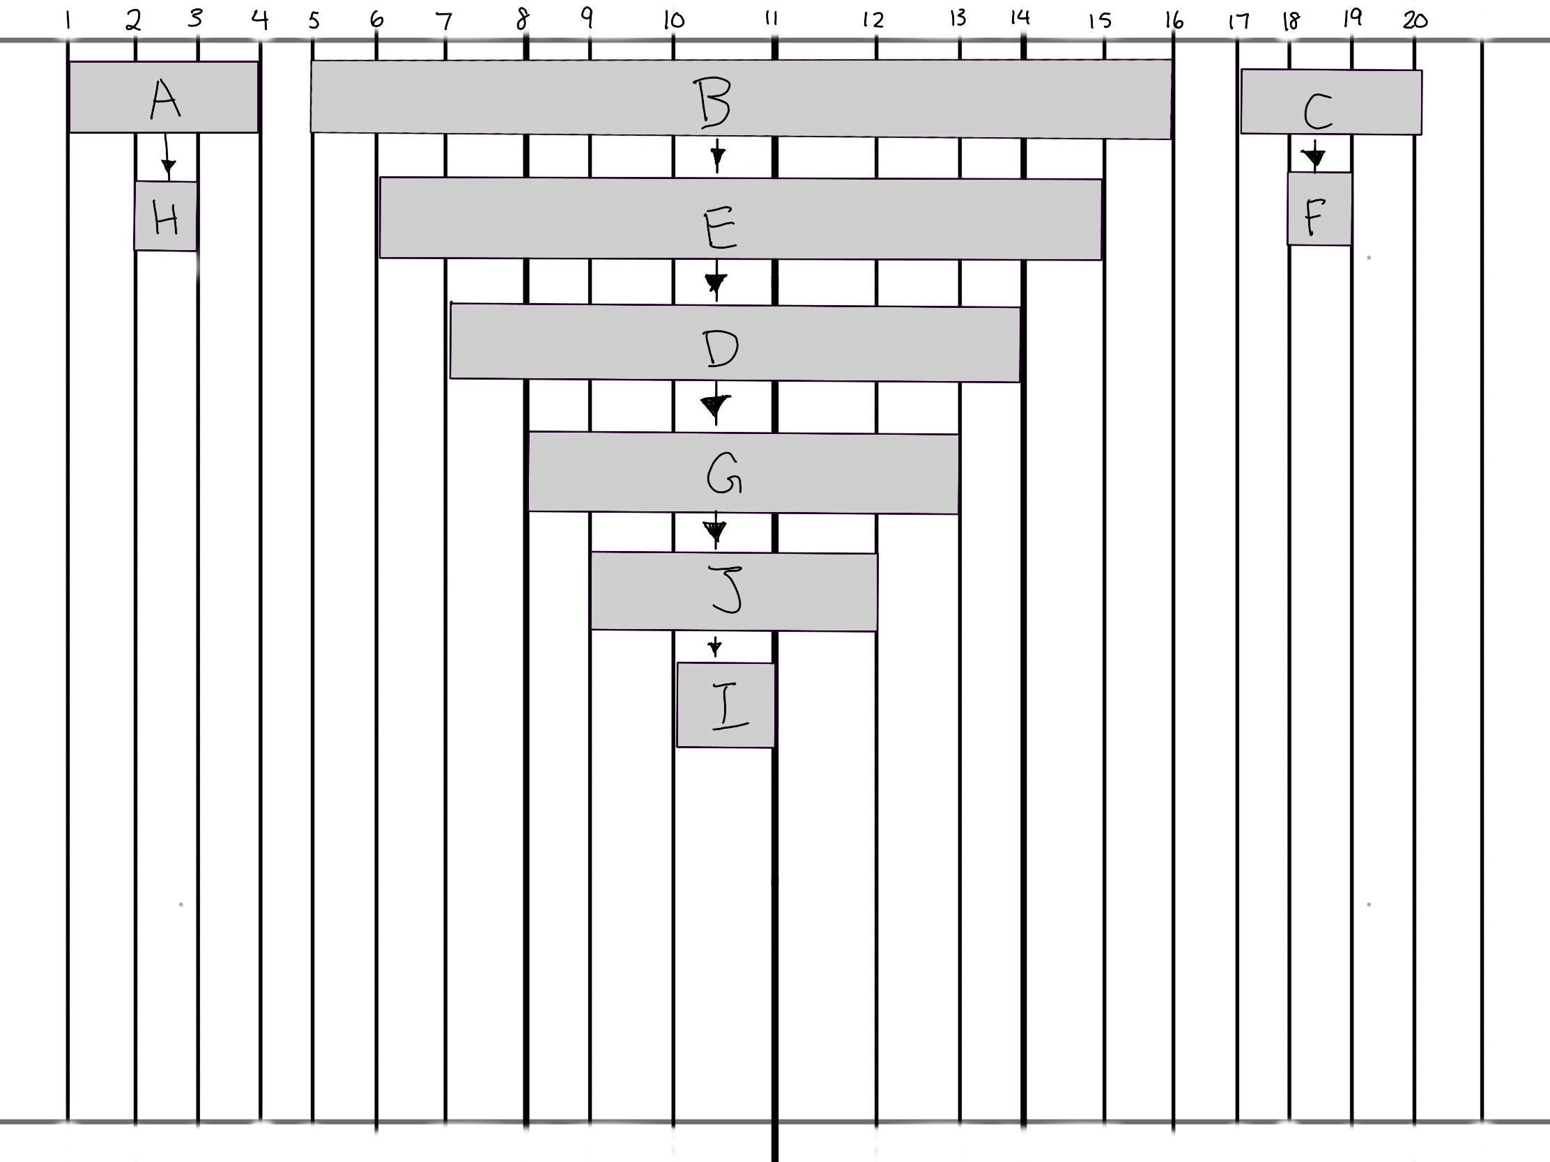

**6) Component Graph GSCC of G**

